**Lab Manual**

**Java Database connectivity (JDBC):**

* *It is a standard Java API for database-independent connectivity between the java programming language and a wide range of databases”.*
* JDBC or Java Database Connectivity is a Java API to connect and execute the query with the database. It is a specification from Sun microsystems that provides a standard abstraction (API or Protocol) for java applications to communicate with various databases. It provides the language with java database connectivity standards. It is used to write programs required to access databases. JDBC, along with the database driver, can access databases and spreadsheets. The data stored in a relational database(RDB) can be accessed with the help of JDBC APIs.

**JDBC Architecture:**

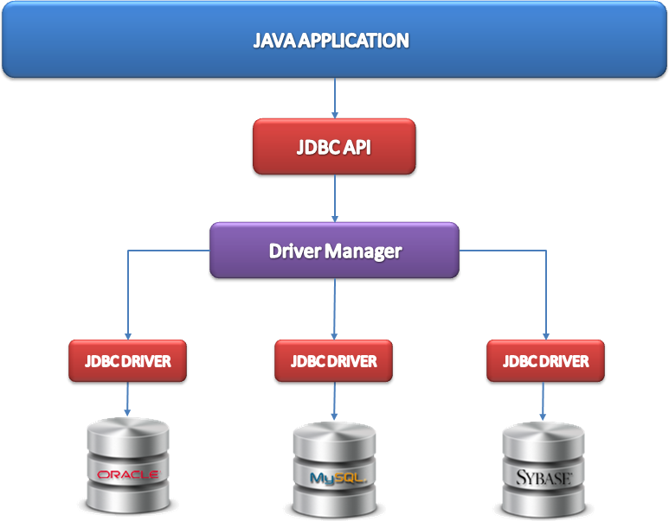

**Steps to Create JDBC Application:**

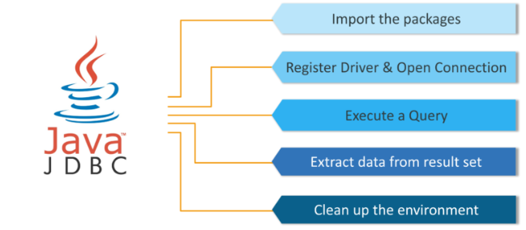

**JDBC Common Packages:**

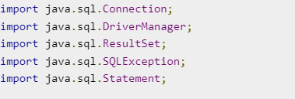

*Java.sql. * contains all packages/classes required for jdbc.*

**Introduction to MySQL:**

**What is MySQL?**

MySQL is a relational database management system (RDBMS) developed by Oracle that is based on structured query language (SQL).

A database is a structured collection of data. It may be anything from a simple shopping list to a picture gallery or a place to hold the vast amounts of information in a corporate network. In particular, a relational database is a digital store collecting data and organizing it according to the relational model. In this model, tables consist of rows and columns, and relationships between data elements all follow a strict logical structure. An RDBMS is simply the set of software tools used to actually implement, manage, and query such a database.

**How to download MySQL:**

<https://www.youtube.com/watch?v=WuBcTJnIuzo>

To connect java application with the mysql database, **mysqlconnector.jar** file is required to be loaded.

Two ways to load the jar file:

1. Paste the mysqlconnector.jar file in jre/lib/ext folder
2. Set classpath

1) Paste the mysqlconnector.jar file in JRE/lib/ext folder:

2) Set classpath: There are two ways to set the classpath:

1. temporary
2. permanent

**How to set the temporary classpath:**

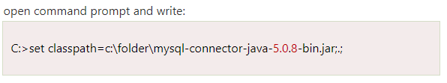

**How to set the permanent classpath:**

Go to environment variable then click on new tab. In variable name write **classpath** and in variable value paste the path to the mysqlconnector.jar file by appending mysqlconnector.jar;.; as C:\folder\mysql-connector-java-5.0.8-bin.jar;.;

You can also use the following tutorial to set class path: <https://www.youtube.com/watch?v=2PFPj3NLmGw&t=310s>

You can download mysqlconnector from

<https://mvnrepository.com/artifact/mysql/mysql-connector-java/8.0.26>

**CRUD Operations:**

Create database employee_mgmt, table employee with 2 attriutes (id (int), name (varchar(255)) in mysql. Insert some data in employee table.

Execute following queries:

**Read Data:**

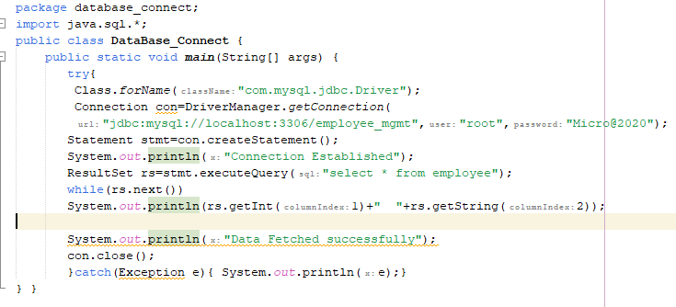

**Insert Data:**

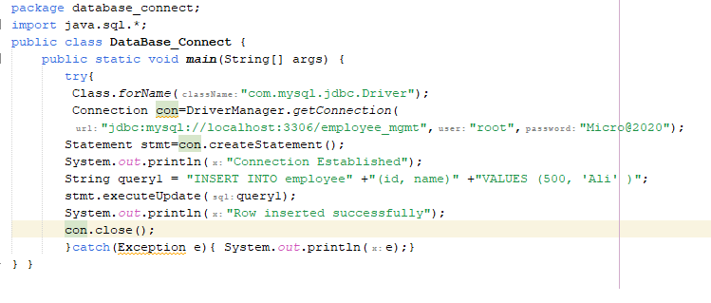

**Update Data:**

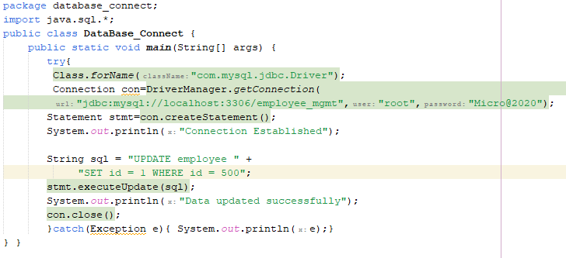

**Delete Data:**

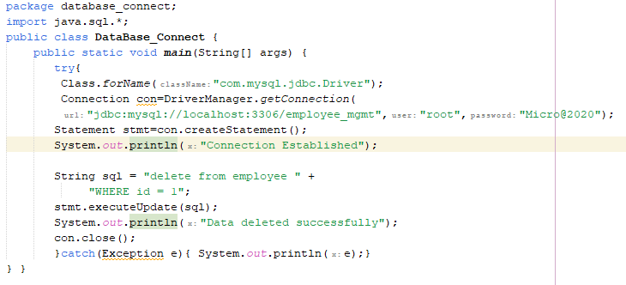

So we need to know following informations for the mysql database:

1. **Driver class:**The driver class for the mysql database is **com.mysql.jdbc.Driver**.
2. **Connection URL:**The connection URL for the mysql database is **jdbc:mysql://localhost:3306/employee_mgmt** where jdbc is the API, mysql is the database, localhost is the server name on which mysql is running, we may also use IP address, 3306 is the port number and **employee_mgmt**  is the database name. We may use any database, in such case, we need to replace the **employee_mgmt**  with our database name.
3. **Username:**The default username for the mysql database is **root**.
4. **Password:**It is the password given by the user at the time of installing the mysql database. In this example, we are going to use Micro@2020 as the password.